

**JAVA and J2EE PROJECT**

TAXI BOOKING MANAGEMENT SYSTEM

Presented by

|  |  |
| --- | --- |
| Aritra Chatterjee | 1MS16IS123 |
| Varun Khanna | 1MS16IS112 |
| Vishal Chavan | 1MS16IS115 |

**Under the guidance of**

**Dr. Sumana Maradithaya**

**Associate Professor, Dept. of ISE**

**INTRODUCTION**

The objective of this project is to create a Taxi Booking system for customers to book a taxi in their given location, and for the administrators of the service to be able to access customer details and their cab details, and to end trips as they deem fit. The system allows for customers to book cabs of two denominations: Regular and Mini. A customer can book only one cab at a time.

**WORKING**

The system works by first displaying a login page, that can be used by customers and administrators alike. Administrators have a set username and password. Customers can register their login details by pressing a Register here button under New Customer.

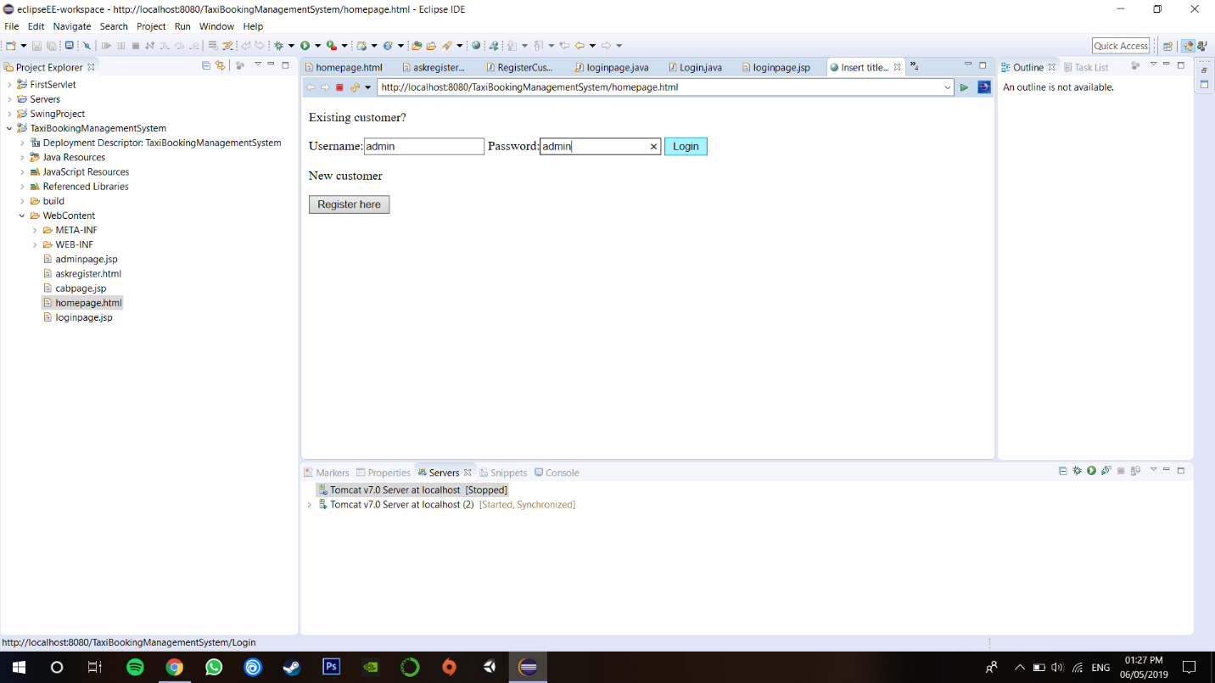

These details are then added to a database in SQL, using JDBC commands. There also exists a database of cabs that the booking system offers.

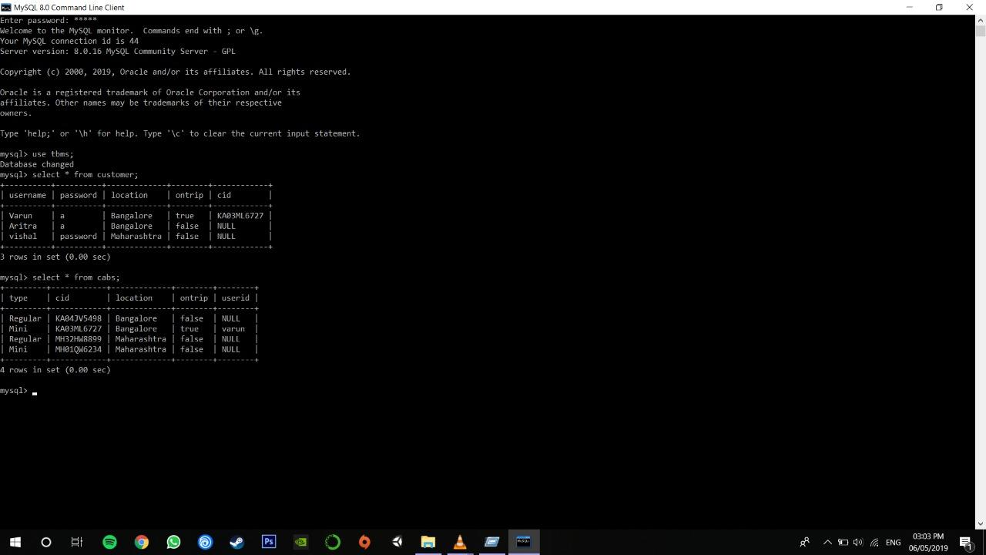

As an administrator, the user can end the trip of a particular customer when the trip reaches its completion. He can also check on which cabs are still on trip, and the customers to which the cabs have been assigned.

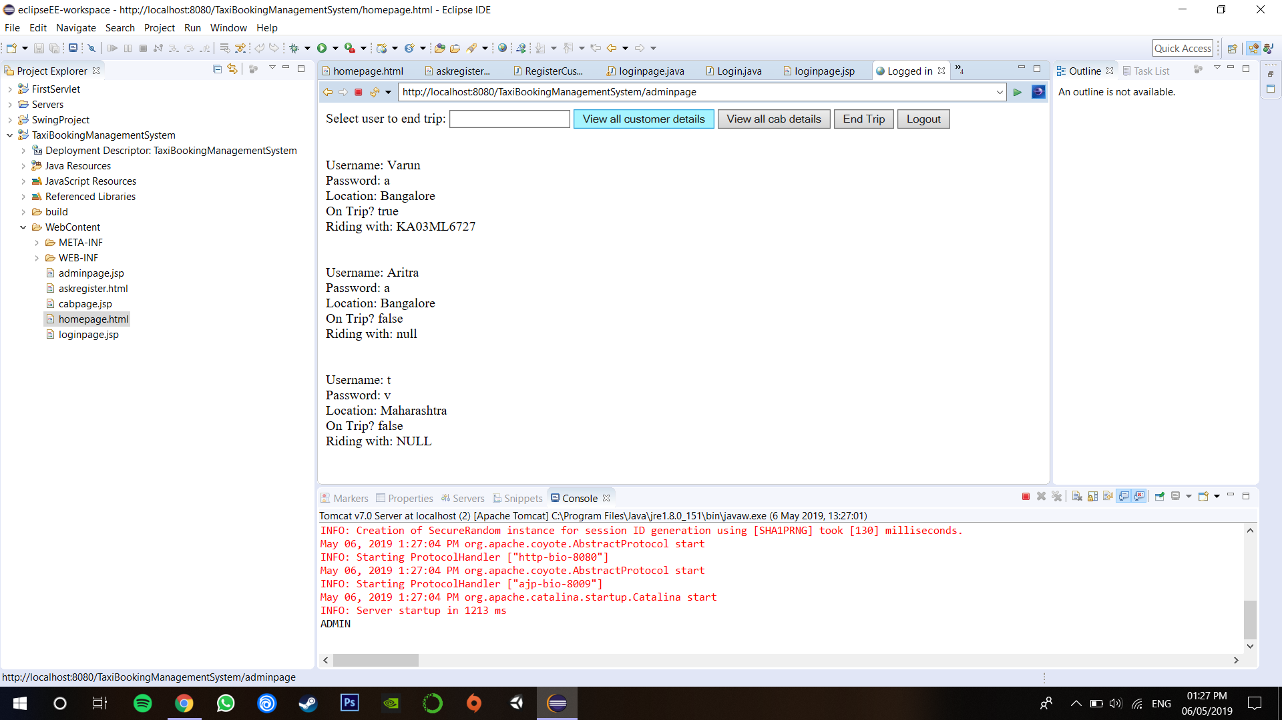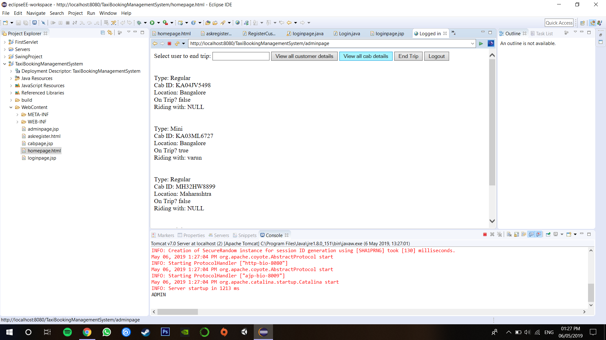

Once a customer creates an account successfully, they can login using those details without having to create an account again.

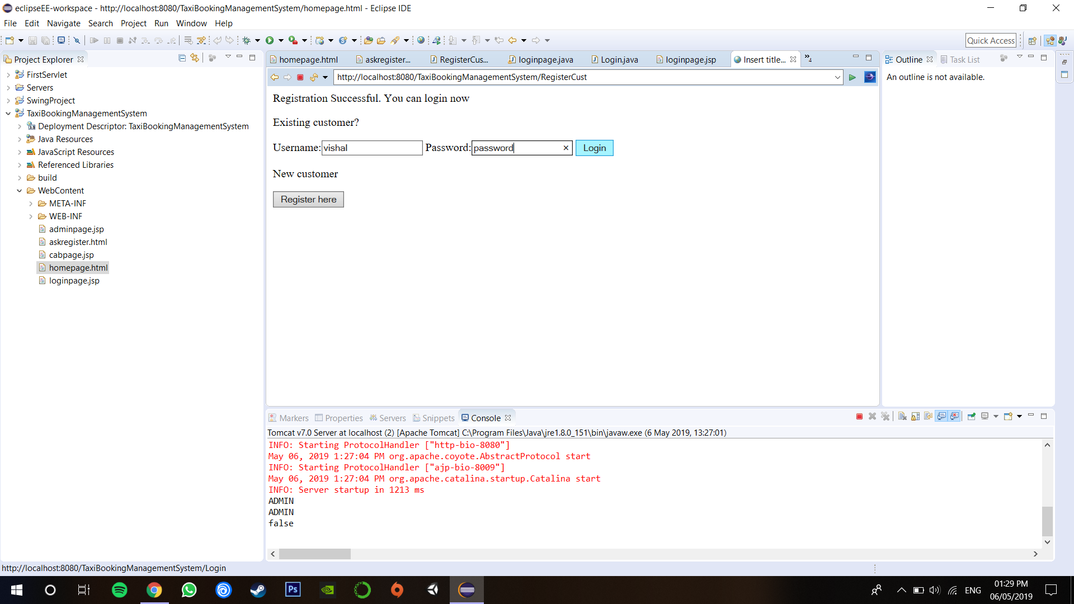

If the details provided by the customer exist in the database they are redirected to the login page.

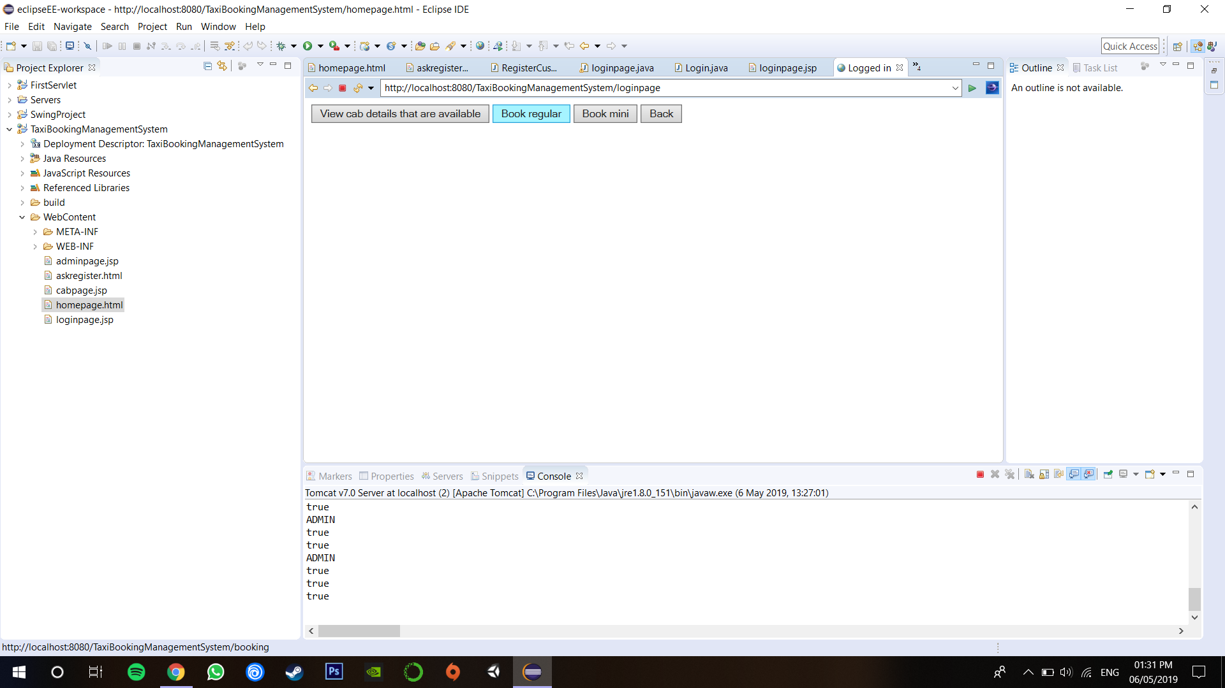

Once logged in the customer has the option to view their personal information, delete their account, book a cab or logout of their account wherein they will be redirected to the login page.

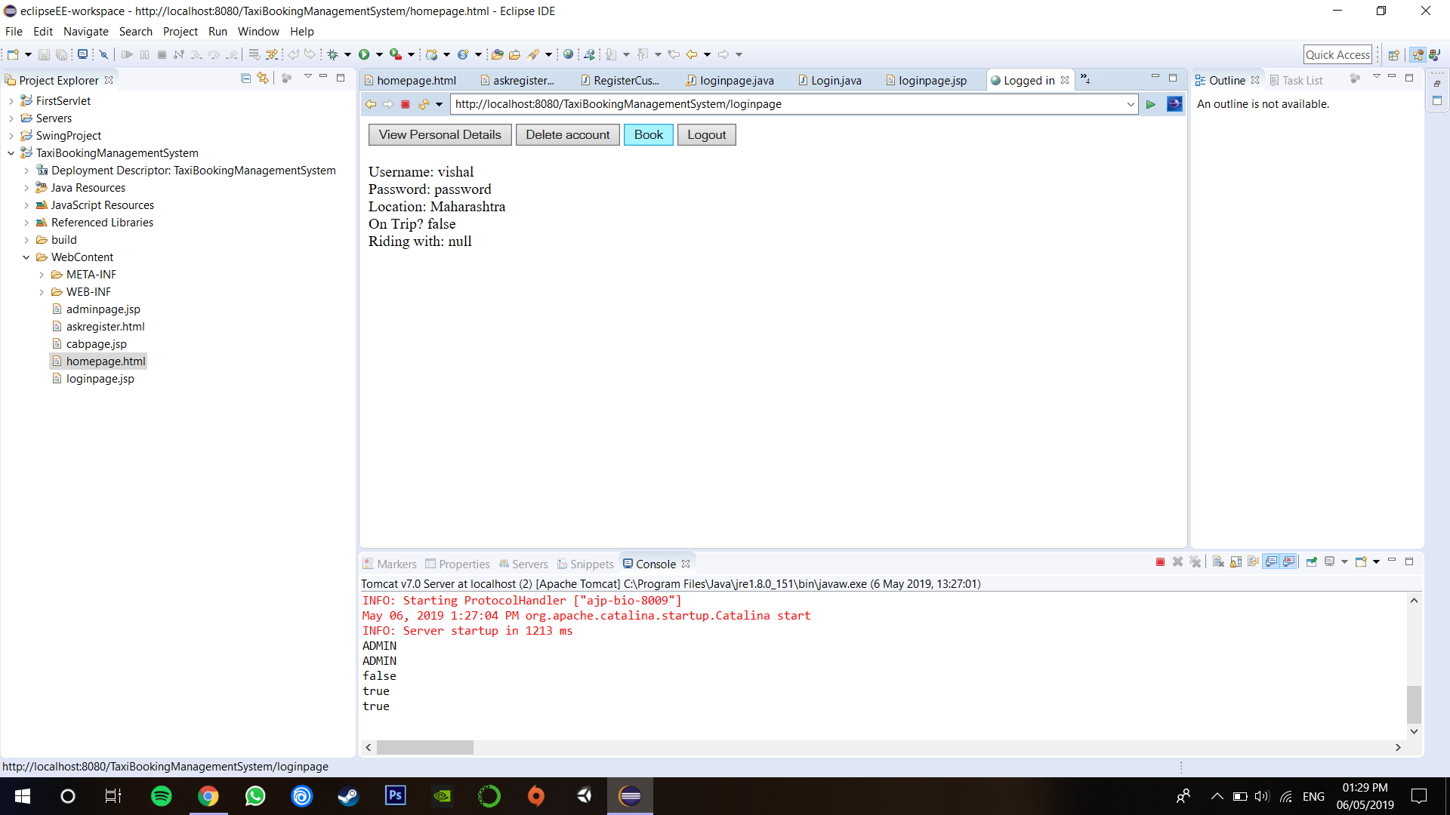If the customer wishes to check the cabs available, the database is checks for cabs regardless of location.

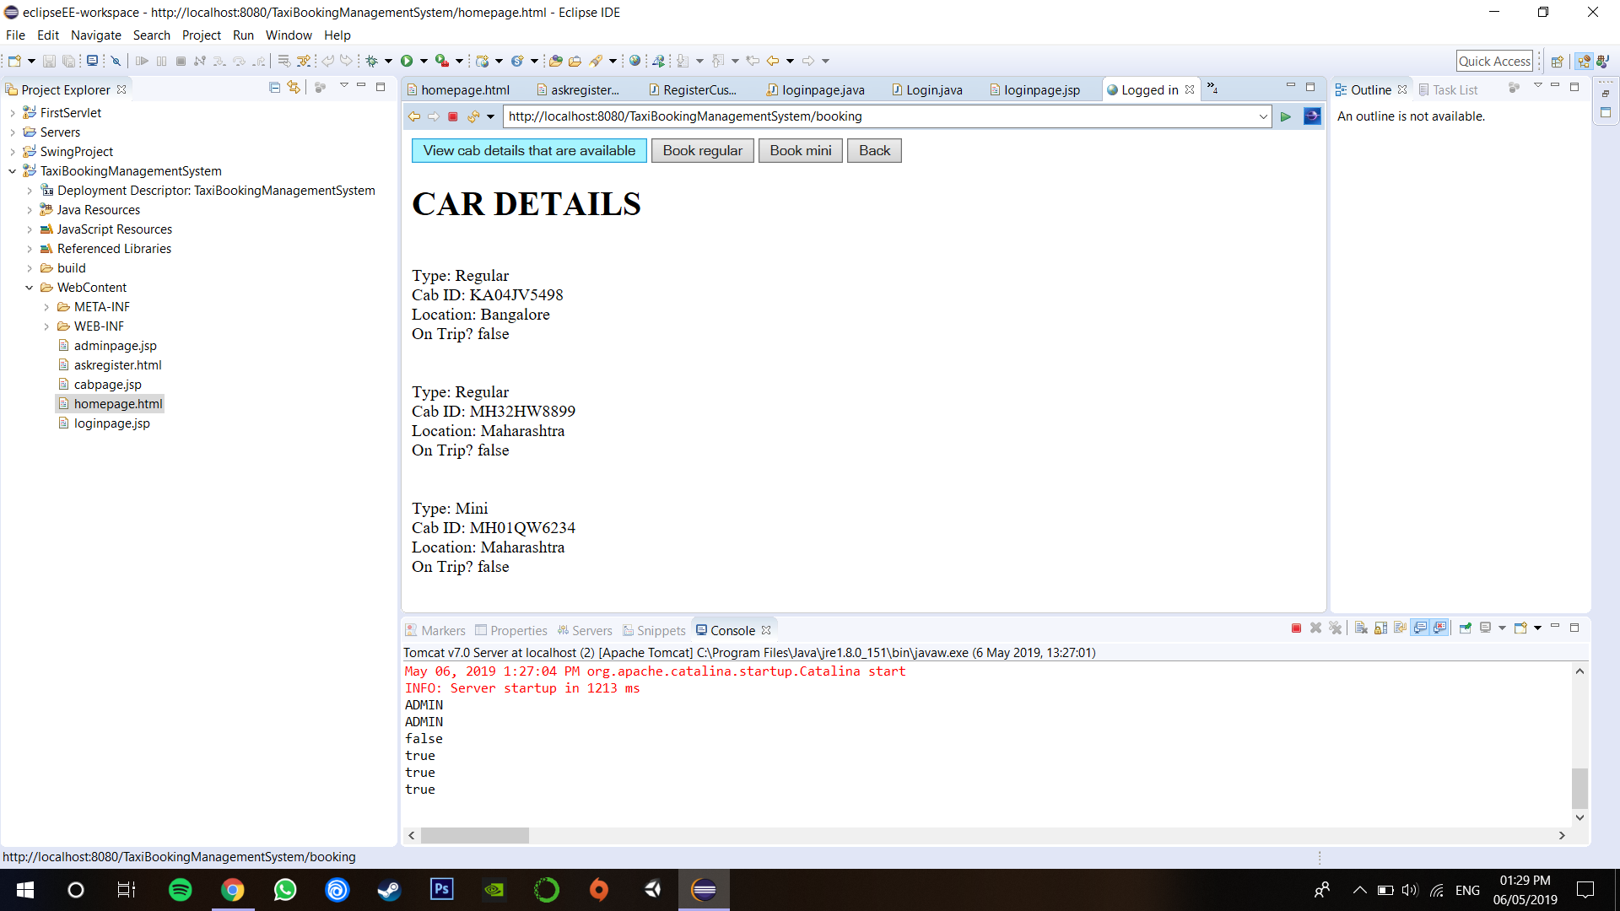

If the customer is already on a trip then they cannot book another. An appropriate message is displayed.

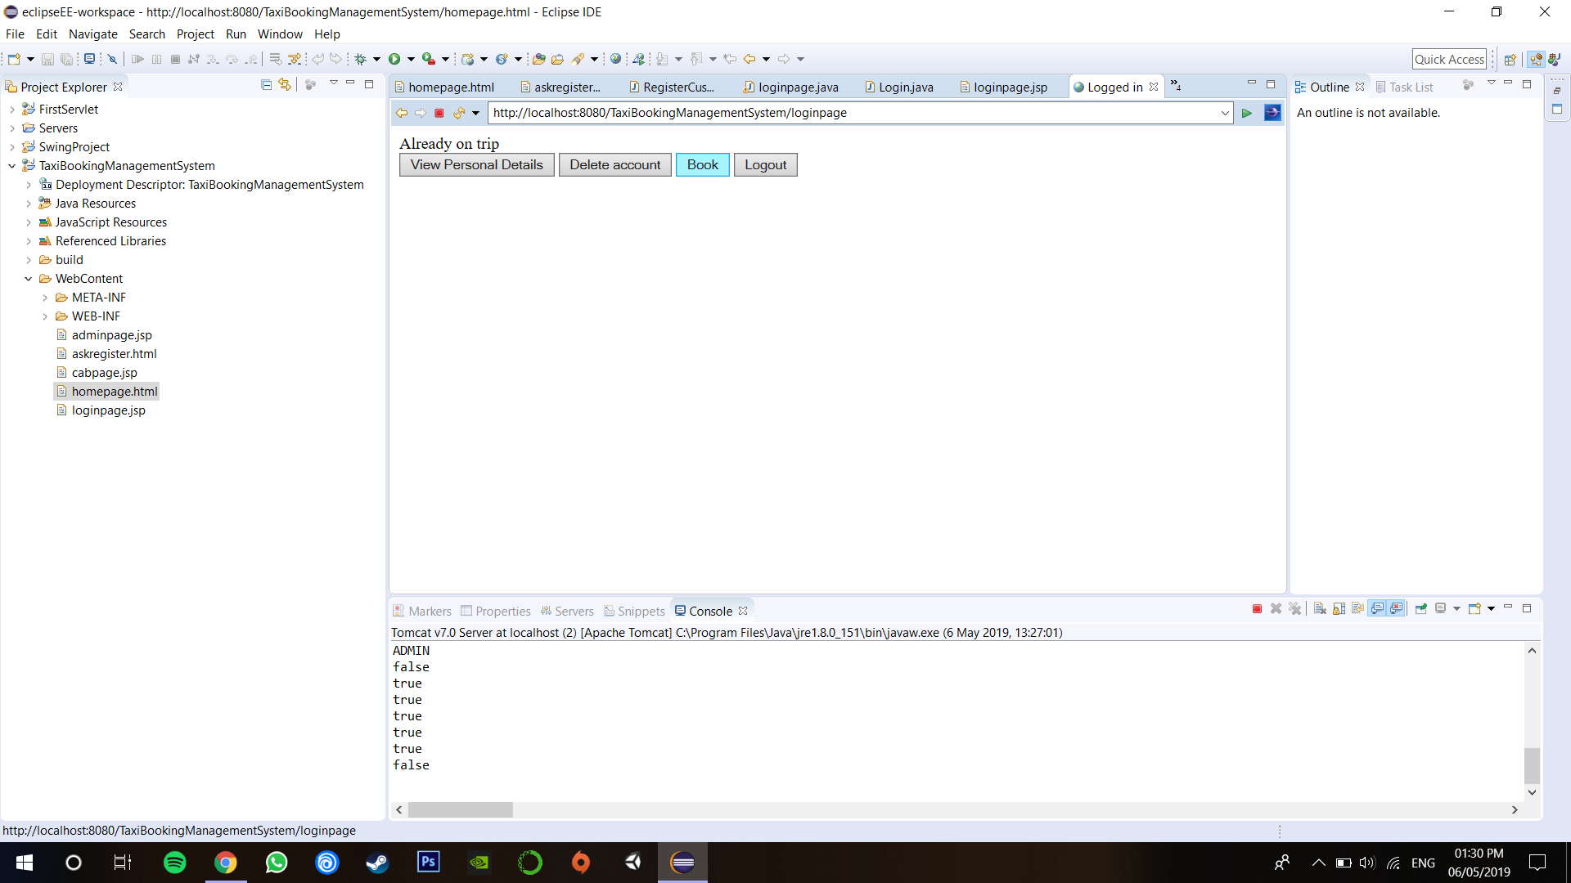

If a given type of cab (Regular or Mini) is unavailable, the appropriate message is displayed.

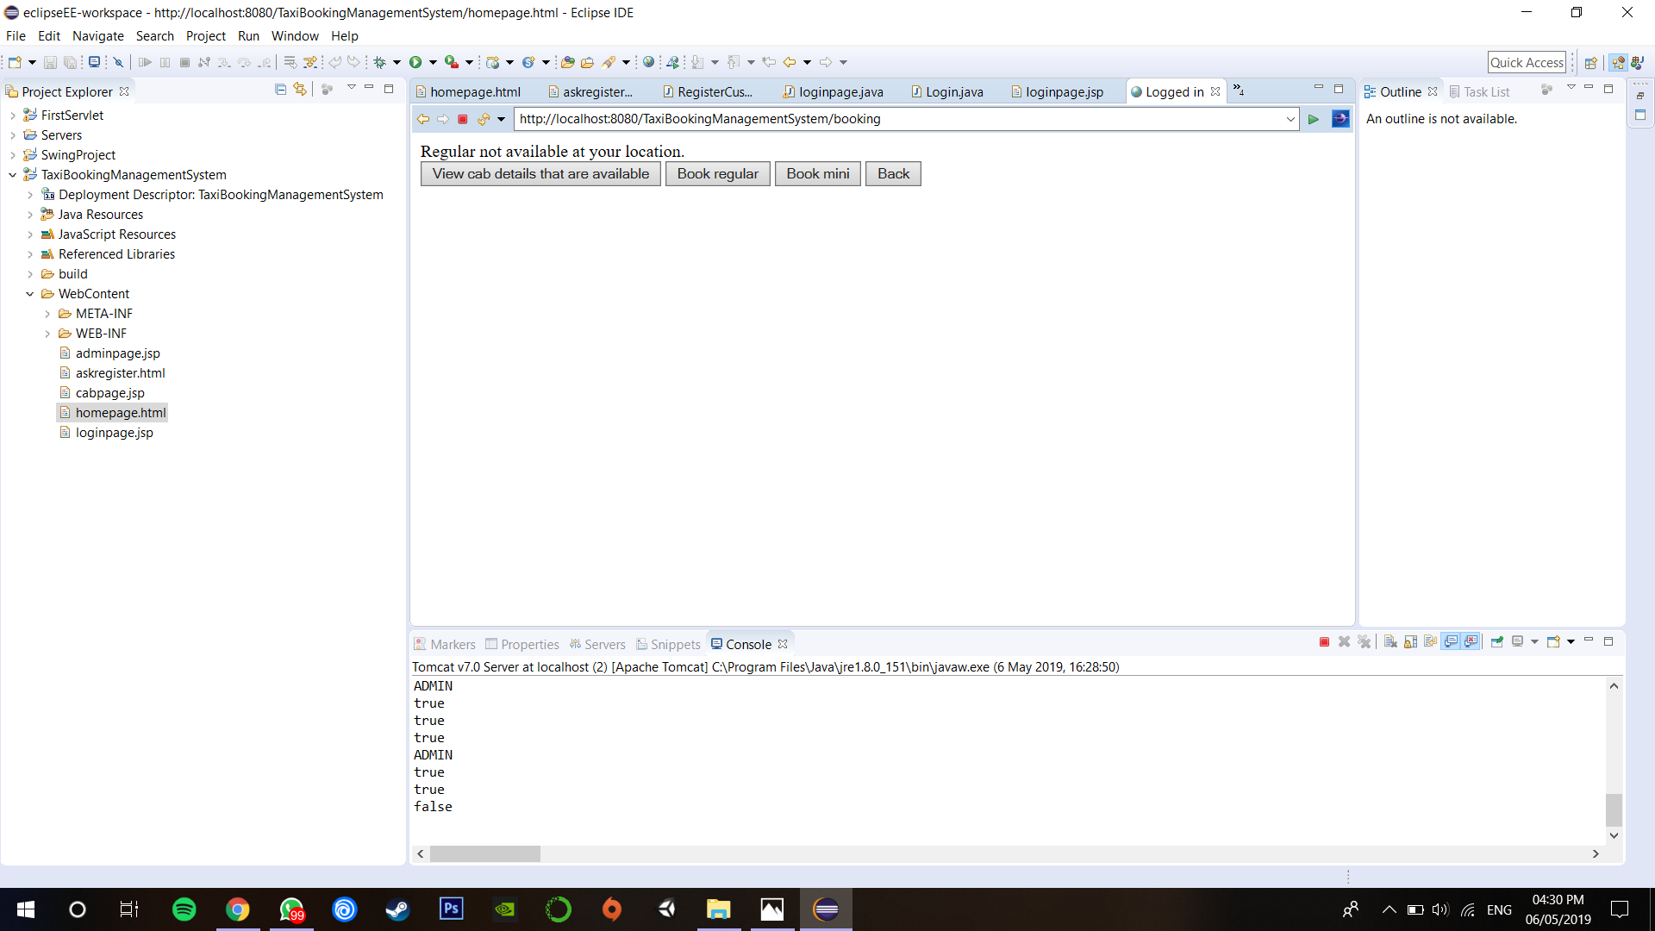

**MODULES IDENTIFIED:**

Java files:

* Adminpage.java: The homepage for administrators who have logged in.
* Booking.java: The page used by users to book cabs.
* Login.java: The page used to log in to the system.
* RegisterCust.java: Used to take the user’s details to register a new customer and enter them in the SQL databases.

JSP Files:

* Adminpage.jsp: The page generated when an administrator logs in.
* Cabpage.jsp: The page generated when a cab has been booked, displaying associated details.
* Loginpage.jsp: The page generated to log in an existing or a new customer.

**RESULTS:**

A basic taxi booking management system is accomplished. The system works by using a JSP servlet for the front end client and the Java code for the application functions. In the backend, MySQL is used as the database management system for storing and managing the user data. The functions used for the database are handled by the JDBC connector to process queries to the database from the client and administrators.